**EXAMEN DE ECONOMETRÍA II**

**(Duración: 1 hora)**

1. Suponga el siguiente modelo de ecuaciones simultáneas y utilice la información obtenida del BCRP (1950-2019)

**Yt = CPt + CGt + IBt + Xt – Mt**

**IBt = IPt + IGt + STOCKt**

**CPt = a1 + a2Yt**

**IP = a3 + a4 Yt-1 + a5 Mt**

**Mt = a6 + a7 TIt + a8 Yt + a9 RINt**

1. Con base al modelo estimado por el método de mínimos cuadrados de dos etapas y además suponiendo que entre el 2020 y 2024 las variables exógenas evolucionan según su tendencia (1950-2019), mediante una simulación obtenga la tasa de crecimiento promedio anual de nuestra economía en los próximos 5 años.

inst CP X IG STOCK Y(-1) TI RIN

Y=CP+CG+IB+X-M

IB=IP+IG+STOCK

CP=C(1)+C(2)*Y

IP=C(3)+C(4)*Y(-1)+C(5)*M

M=C(6)+C(7)*TI+C(8)*Y+C(9)*RIN

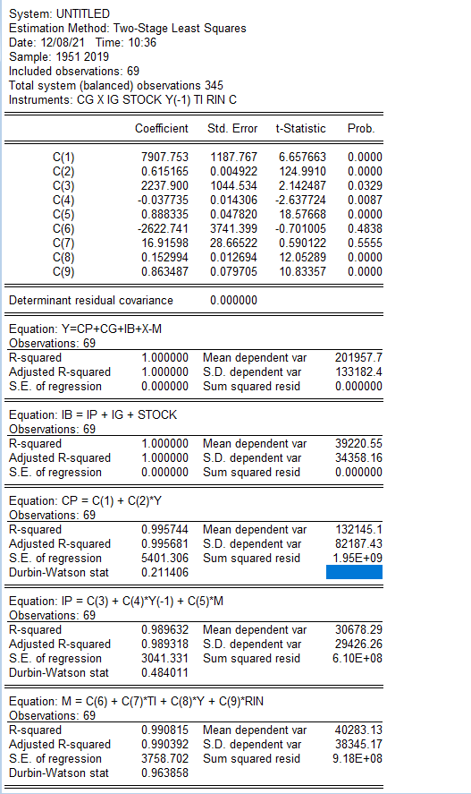

Hallando la tasa de crecimiento de Consumo de gob desde 1950 a 2019

|  |  |  |  |  |
| --- | --- | --- | --- | --- |
| Dependent Variable: LCG | | | | |
| Method: Least Squares | | | | |
| Date: 12/08/21 Time: 11:11 | | | | |
| Sample: 1950 2019 | | | | |
| Included observations: 70 | | | | |
| Variable | Coefficient | Std. Error | t-Statistic | Prob. |
| C | 8.605279 | 0.066258 | 129.8759 | 0.0000 |
| TIME | 0.033943 | 0.001622 | 20.92571 | 0.0000 |
| R-squared | 0.865582 | Mean dependent var | | 9.810265 |
| Adjusted R-squared | 0.863605 | S.D. dependent var | | 0.742484 |
| S.E. of regression | 0.274211 | Akaike info criterion | | 0.278320 |
| Sum squared resid | 5.113047 | Schwarz criterion | | 0.342563 |
| Log likelihood | -7.741205 | F-statistic | | 437.8854 |
| Durbin-Watson stat | 0.072396 | Prob(F-statistic) | | 0.000000 |

**CG =3.3943 %**

**Teniendo la tasa de crecimiento proyectamos para los próximos 5 años la variable CG (2020 2024)**

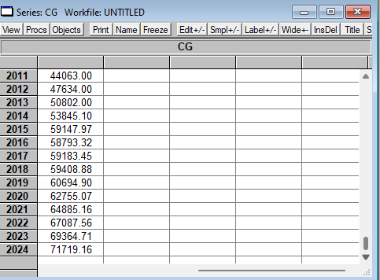

|  |  |  |  |  |
| --- | --- | --- | --- | --- |
| Dependent Variable: LX | | | | |
| Method: Least Squares | | | | |
| Date: 12/08/21 Time: 11:12 | | | | |
| Sample: 1950 2019 | | | | |
| Included observations: 70 | | | | |
| Variable | Coefficient | Std. Error | t-Statistic | Prob. |
| C | 8.880243 | 0.050314 | 176.4961 | 0.0000 |
| TIME | 0.042353 | 0.001232 | 34.38375 | 0.0000 |
| R-squared | 0.945611 | Mean dependent var | | 10.38376 |
| Adjusted R-squared | 0.944811 | S.D. dependent var | | 0.886362 |
| S.E. of regression | 0.208228 | Akaike info criterion | | -0.272213 |
| Sum squared resid | 2.948399 | Schwarz criterion | | -0.207970 |
| Log likelihood | 11.52745 | F-statistic | | 1182.242 |
| Durbin-Watson stat | 0.145826 | Prob(F-statistic) | | 0.000000 |

**X = 4.2353%**

**Teniendo la tasa de crecimiento proyectamos para los próximos 5 años la variable X (2020 2024)**

|  |  |  |  |  |
| --- | --- | --- | --- | --- |
| Dependent Variable: LIG | | | | |
| Method: Least Squares | | | | |
| Date: 12/08/21 Time: 11:13 | | | | |
| Sample: 1950 2019 | | | | |
| Included observations: 70 | | | | |
| Variable | Coefficient | Std. Error | t-Statistic | Prob. |
| C | 7.223910 | 0.108029 | 66.86985 | 0.0000 |
| TIME | 0.042432 | 0.002645 | 16.04425 | 0.0000 |
| R-squared | 0.791038 | Mean dependent var | | 8.730263 |
| Adjusted R-squared | 0.787965 | S.D. dependent var | | 0.970928 |
| S.E. of regression | 0.447086 | Akaike info criterion | | 1.256023 |
| Sum squared resid | 13.59224 | Schwarz criterion | | 1.320266 |
| Log likelihood | -41.96082 | F-statistic | | 257.4180 |
| Durbin-Watson stat | 0.296310 | Prob(F-statistic) | | 0.000000 |

**IG = 4.2432 %**

|  |  |  |  |  |
| --- | --- | --- | --- | --- |
| Dependent Variable: LSTOCK | | | | |
| Method: Least Squares | | | | |
| Date: 12/08/21 Time: 11:14 | | | | |
| Sample: 1950 2019 | | | | |
| Included observations: 70 | | | | |
| Variable | Coefficient | Std. Error | t-Statistic | Prob. |
| C | 5.381792 | 0.248570 | 21.65101 | 0.0000 |
| TIME | 0.045555 | 0.006085 | 7.485980 | 0.0000 |
| R-squared | 0.451789 | Mean dependent var | | 6.998987 |
| Adjusted R-squared | 0.443727 | S.D. dependent var | | 1.379284 |
| S.E. of regression | 1.028721 | Akaike info criterion | | 2.922665 |
| Sum squared resid | 71.96217 | Schwarz criterion | | 2.986908 |
| Log likelihood | -100.2933 | F-statistic | | 56.03989 |
| Durbin-Watson stat | 1.824215 | Prob(F-statistic) | | 0.000000 |

**STOCK = 4.5555%**

|  |  |  |  |  |
| --- | --- | --- | --- | --- |
| Dependent Variable: LTI | | | | |
| Method: Least Squares | | | | |
| Date: 12/08/21 Time: 11:15 | | | | |
| Sample: 1950 2019 | | | | |
| Included observations: 70 | | | | |
| Variable | Coefficient | Std. Error | t-Statistic | Prob. |
| C | 4.643693 | 0.051897 | 89.47875 | 0.0000 |
| TIME | -0.004885 | 0.001271 | -3.844949 | 0.0003 |
| R-squared | 0.178582 | Mean dependent var | | 4.470273 |
| Adjusted R-squared | 0.166502 | S.D. dependent var | | 0.235256 |
| S.E. of regression | 0.214779 | Akaike info criterion | | -0.210256 |
| Sum squared resid | 3.136852 | Schwarz criterion | | -0.146013 |
| Log likelihood | 9.358944 | F-statistic | | 14.78363 |
| Durbin-Watson stat | 0.176571 | Prob(F-statistic) | | 0.000268 |

**TI = -0.4858%**

|  |  |  |  |  |
| --- | --- | --- | --- | --- |
| Dependent Variable: LRIN | | | | |
| Method: Least Squares | | | | |
| Date: 12/08/21 Time: 11:18 | | | | |
| Sample(adjusted): 1959 2019 | | | | |
| Included observations: 61 after adjusting endpoints | | | | |
| Variable | Coefficient | Std. Error | t-Statistic | Prob. |
| C | 2.682784 | 0.224972 | 11.92499 | 0.0000 |
| TIME | 0.123557 | 0.005148 | 24.00254 | 0.0000 |
| R-squared | 0.907104 | Mean dependent var | | 7.625075 |
| Adjusted R-squared | 0.905530 | S.D. dependent var | | 2.303084 |
| S.E. of regression | 0.707875 | Akaike info criterion | | 2.179140 |
| Sum squared resid | 29.56416 | Schwarz criterion | | 2.248349 |
| Log likelihood | -64.46376 | F-statistic | | 576.1221 |
| Durbin-Watson stat | 0.741188 | Prob(F-statistic) | | 0.000000 |

**RIN = 12.3557%**

data RIN CP CG IP IG STOCK X M TI

genr IB=IG+IP+STOCK

genr Y=CP+CG+IB+X-M

data time

smpl 1951 2019

genr time=time(-1)+1

smpl 1950 2019

genr lCG=log(CG)

genr lX=log(X)

genr lIG=log(IG)

genr lSTOCK=log(STOCK)

genr lRIN=log(RIN)

genr lTI=log(TI)

ls lCG c time

ls lX c time

ls lIG c time

ls lSTOCK c time

ls lTI c time

ls lRIN c time

range 1950 2024

smpl 2020 2024

genr CG=CG(-1)*(1+0.033943)

genr X=X(-1)*(1+0.042353)

genr IG=IG(-1)*(1+0.042432)

genr STOCK=STOCK(-1)*(1+0.045555)

genr TI=TI(-1)*(1-0.004885)

genr RIN=RIN(-1)*(1+0.123557)

1. **Ahora suponiendo que entre el 2020 y 2024 se espera una tasa de crecimiento de las variables exógenas de:**

**CG = 2%**

**X = 5%**

**IG = - 15%**

**STOCK = 10%**

**TI = 3%**

**RIN = 10%**

genr CG=CG(-1)*(1+0.02)

genr X=X(-1)*(1+0.05)

genr IG=IG(-1)*(1+0.15)

genr STOCK=STOCK(-1)*(1+0.10)

genr TI=TI(-1)*(1+0.03)

genr RIN=RIN(-1)*(1+0.10)

smpl 1950 2024

**Mediante una simulación obtenga la tasa de crecimiento promedio anual de nuestra economía en los próximos 5 años.**

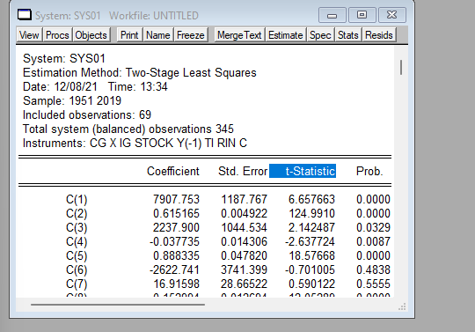

RESUMEN DE COMANDOS

**genr time=time(-1)+1**

**smpl 1950 2019**

**genr lTI=log(TI)**

**genr lCG=log(CG)**

**genr lX=log(X)**

**genr lIG=log(IG)**

**genr lSTOCK=log(STOCK)**

**genr lRIN=log(RIN)**

**ls lCG c time**

**ls lX c time**

**ls lIG c time**

**ls lSTOCK c time**

**ls lTI c time**

**ls lRIN c time**

**range 1950 2024**

**smpl 2020 2024**

**genr CG=CG(-1)*(1+0.033943)**

**genr X=X(-1)*(1+0.042353)**

**genr IG=IG(-1)*(1+0.042432)**

**genr STOCK=STOCK(-1)*(1+0.045555)**

**genr TI=TI(-1)*(1-0.004885)**

**genr RIN=RIN(-1)*(1+0.123557)**

**genr CG=CG(-1)*(1+0.02)**

**genr X=X(-1)*(1+0.05)**

**genr IG=IG(-1)*(1-0.15)**

**genr STOCK=STOCK(-1)*(1+0.10)**

**genr TI=TI(-1)*(1+0.03)**

**genr RIN=RIN(-1)*(1+0.10)**

**smpl 1950 2024**

**show IP Y Y(-1) M**

**........................................**

**smpl 1950 2024**

**smpl 1951 201971**